**Introduction to software engineering : 0721110**

**Quiz 1**

1. What are the main differences between a student software and industrial-strength software?

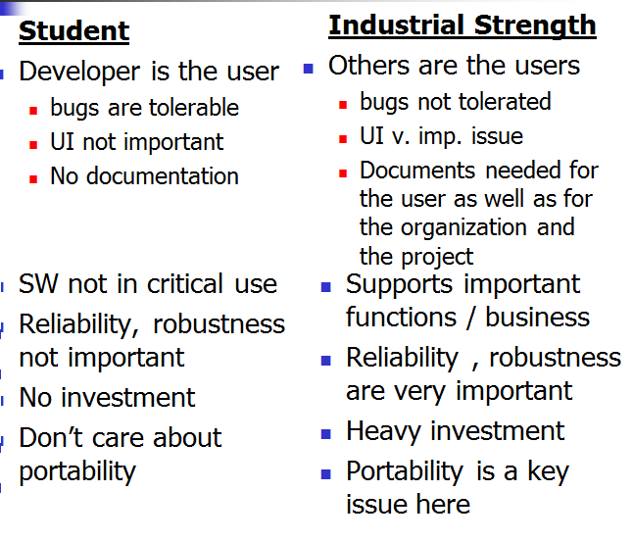

2. If for an accounting software we are most interested in ensuring that the software does not make any computation mistakes, then which of the quality attributes should we be most concerned about?

Reliability and accuracy

3. Suppose changes are to be made to a software system that is in operation. Why will changes to such a system cost a lot more than just making changes to the source code files?

Because lots of activities are done more than once.